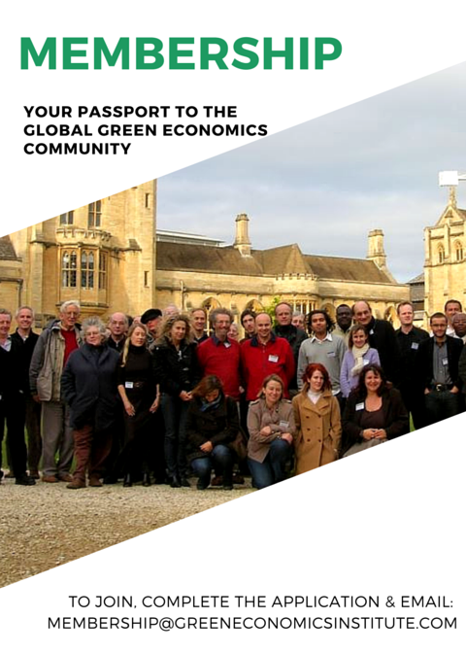
Name
Surname
Title (Dr., Professor, etc.)
Institution (if applicable)
Full postal address
Country
Email address
Best Phone number
Website:

Please let us know the Issues that are most important to you:
Social Justice: | Environmental Justice: | Economic Justice:
- Human Rights  - Healthcare & Well-being  - Agrarian Reform  - Genetically-Modified  - Food & Food Justice Issues  - Animal Welfare  - Corruption & Transparency  - Combating Poverty  - Women's Empowerment & Rights  - Minorities & Indigenous Peoples' Welfare  - Education Reform  - Youth Engagement  - Employment  - Democracy & Gov’t Reform  - Other(s): | - Climate Change  - Biodiversity Loss  - Deforestation  - Pollution & Waste Management  - Ocean Acidification  - Fracking  - Soil Erosion  - Genetically-Modified Crops & Organisms Issues  - Exploitation of Natural Resources  - Overfishing  - Renewable & Alt.Energy  - Nat’l / Int’l Environmental Law & Policy-Making  - Other(s): | - Reforming & Rebalancing Economics  - Banking & Financial System Reform  - Business & Corporate Social Responsibility  - Social Enterprises & Entrepreneurship  - Social Banking & Microfinance  - Supply Chain & Sourcing  - Citizens' Income  - Economic Development  - Women's Unequal Pay & Poverty  - Other(s):

SPECIAL RATE: Expires July 31, 2016.  To celebrate our 11th Annual Green Economics Institute Conference, we are offering a SPECIAL MEMBERSHIP RATE: £45 for 2016 Regular Institute Membership. | Available to the first 100 interested until July 31st, 2016. |  | Email our team to claim your special rate of only £45 for 2016
Membership: Monthly Subscription OR Annual Fees: | Donate Monthly | X | Donate Annually | X
Regular Institute Membership: | £5 / month |  | £60 / year
International Expert Membership:  To apply for this level of membership, please email this form along with your biography & CV. | £10 / month |  | £120 / year
Thank you for your generous donation of support which makes the Institute’s work possible. We look forward to welcoming you to the Green Economics Institute’s International Membership Network and Our Global Green Economics Community.

